Video Tag Portal

User Guide

**Login**

Once a user reaches the site they will be able to login with their Facebook or Google Account.

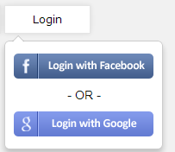

**Login with Google**

**Step 1:**

Users can use their existing Google account or create a new one from the page.

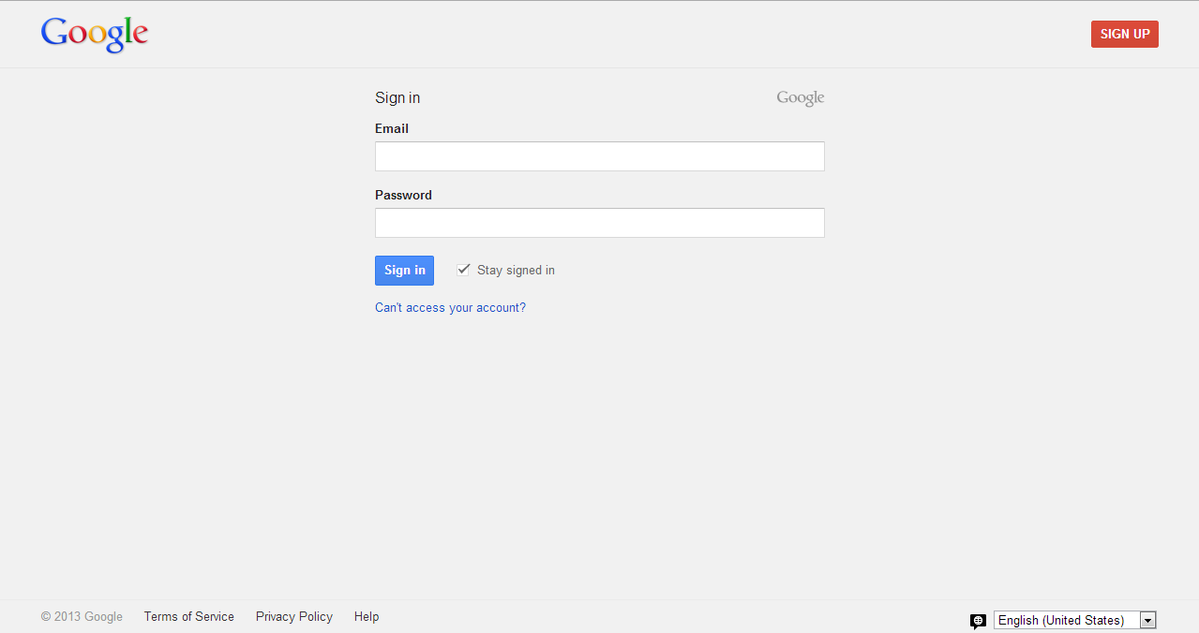

**Step 2:**

Give permississions to “Video Tag Portal”. This step is required for first time users only.

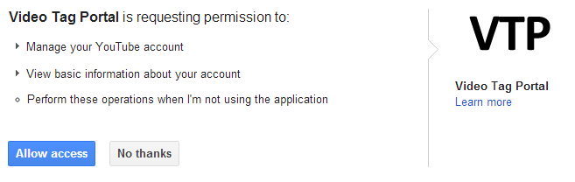

**Login with Facebook**

**Step 1:**

Users can use their existing Facebook account or create a new one from the page.

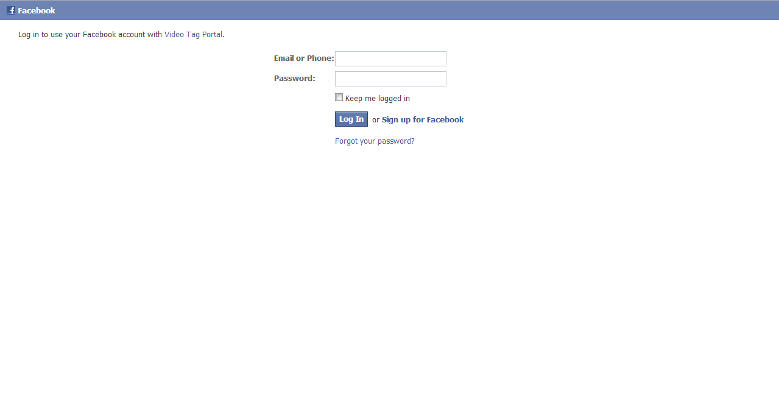

**Step 2:**

Give permissions to Video Tag Portal on Facebook to access your basic information and your friends list. This step is required for first time users only.

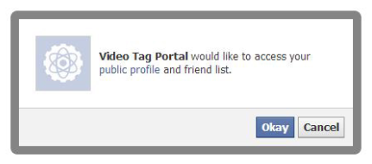

**Logout**

Once the user is logged in he/she can logout by clicking the logout button within same dropdown menu as the login menu.

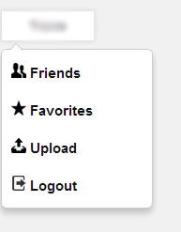

**Search**

Using the search bar on the top of the application the user is able to search any video on YouTube. You can open a video by clicking on it.

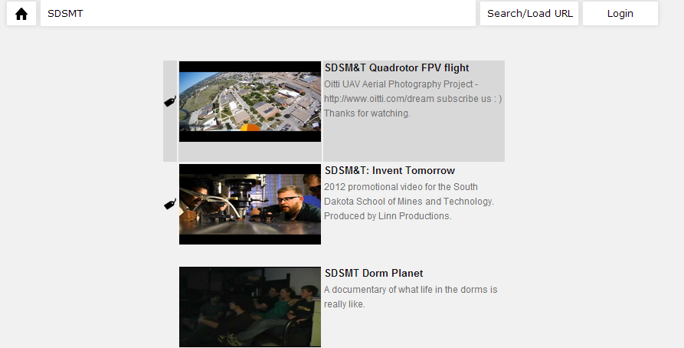

**Add to favorites**

Once the video is loaded in the player you will see an “add to favorites button” that when you click on it, the add to favorites disappears. The next time you open the video you will see the text “Currently in Favorites”.

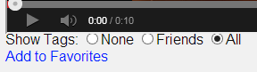

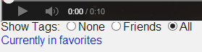

**Open a favorite or an upload**

Open the favorites page by selecting it in the dropdown menu under your name.



Then select the favorite or Upload that you wish to open in the player.

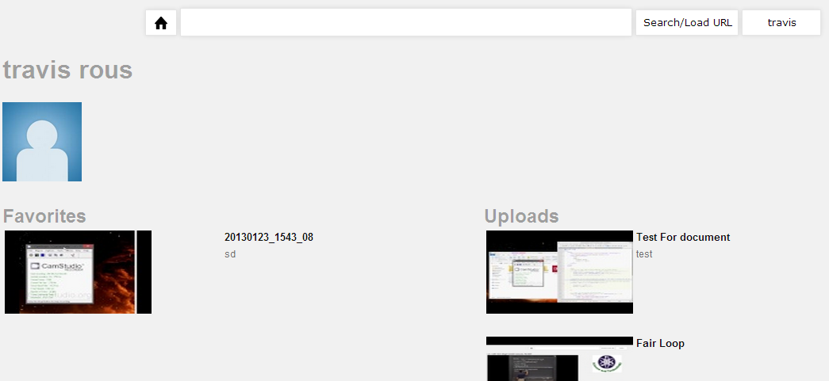

**Open a Friend**

To open a friends page go to the dropdown menu and select Friends.



Once the page is loaded it show look something like this, here you can select the user that you want to view more in detail. The details will be seeing the users Facebook page as well as favorites.

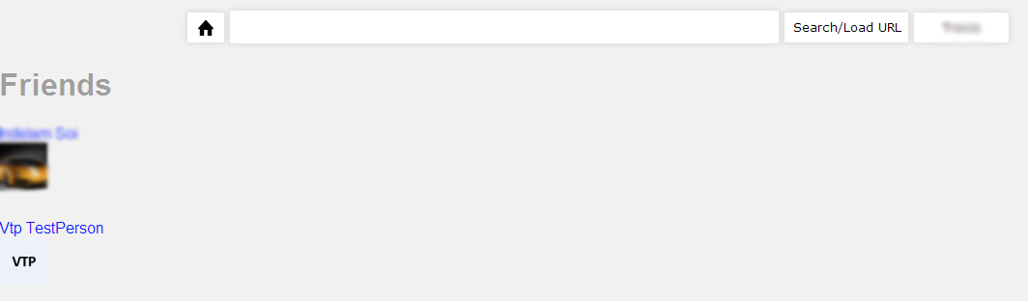

**Upload a Video**

Users can upload videos into YouTube. To upload a video you need to select the Upload button from the dropdown menu.



Now fill out the form and you will be able to choose a file to upload.

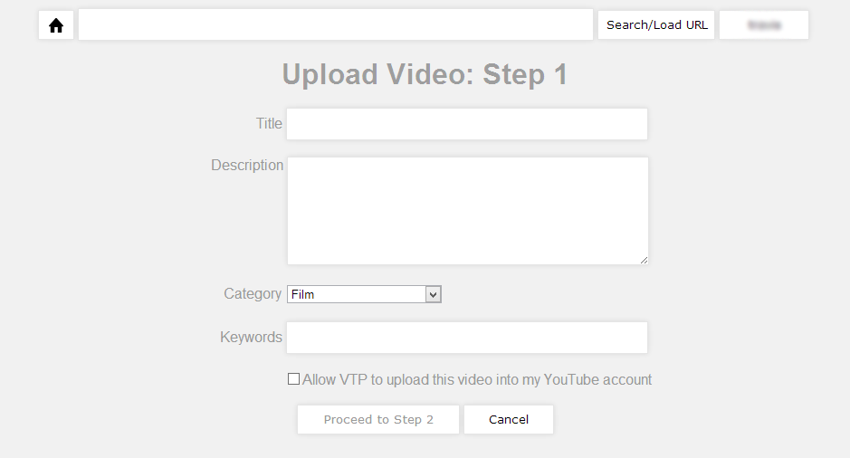

**Adding tags to a video**

To add tags to a video open the video in the player, by doing a search or loading from favorites.

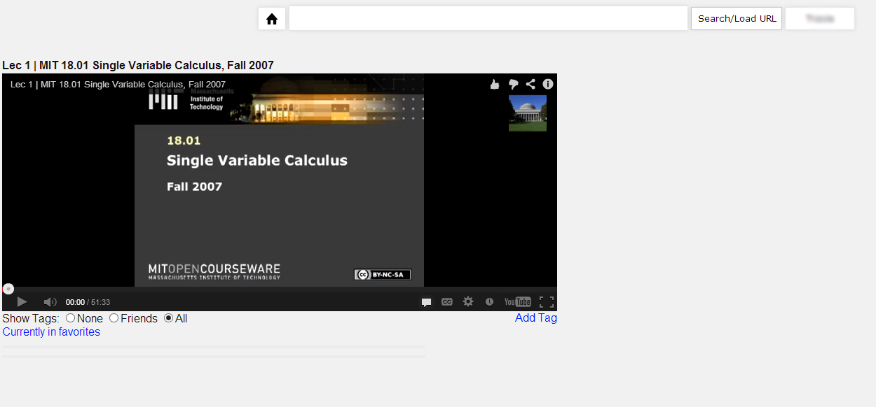­

In the player there is an add tag button to click that opens the tag adding mechanism.

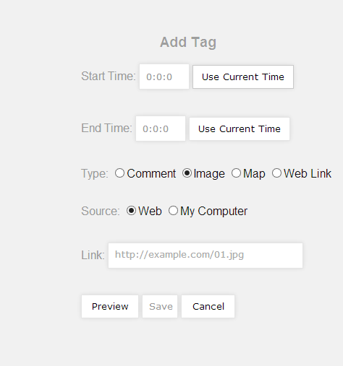

To add the times you need to make the video player get to the point in the video in which you want to grab the time, then click “Use Current Time”. After getting the timings the user only needs to fill out the rest form click save. Then the page will reload with the new tag added.